# --:;--:r::-:::::

.. **1.iy eight BE T *11'1* E .8 N DAVIS COJ\1TI-t.i\GTO.iS**

**ragist0r1ed off·lc:0 is s.ituate at 352 Kllbu.!'n High noad**

oi' Lond<Jn (het:einafta.-• called 11the Lesaor" i,ihich

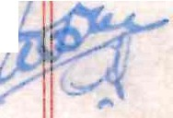e;;p ·e ss:ton shall 1,1he r•e ·the context so pe.t>mit-s inc 1 ude the ?e!·sons **J'or1 the tlme bel 1 e:.ntitled to the reveesion im:r1edi.at0ly ex:pecto.nt** on the d.eter•l inatlon al' -che ter•tr. hfJ_rnby C.t'eated.) of' the first pa1•t **i1:\YM01::SL Lf {E of 38 Lon.g Lane Ickenham in tbo County of' MiddleseY.** (horeinafteI' call"Jd "the Lessee" whicl1 e.xpi1eosion shs:.11 ;mere tl1e contaxt so pe1•,n:tts include the persons derivi!l.g title unde.:" the

**Lessee) of t 1e second pa:r t a.no. :B1L.t:/l1S 1UfG E81AT : NANAG!:;f.1E}rI1 Lil·iITE'D**

***/5"***

whose registe:£>ed office :ls situate at Victorlfl. Stf'eet in the

Cit-y of' Westminster s;,,,.,,l (hereim,.ftet' called "the Company",' of

**the thi:ed pa t**

NO ',I THIS **L E A S E made in considet·at ion of the sum**

rif Tl·/0 TnOUSA.J.IT; FIVE HUN,':;;-;;D AND *Ti:1:"'I'Y* POUNtS paid bJ the Lasses to

the .Lesso!' ( the receipt whe,•eo.t' the Lesso.!' ha!'eby ac:'·.uw\,ledges) and

of the yea.r•ly :e0nt and covenants on the par-t *oi'* the Lessee her-eina_ft21

reser•ved and contained W I T N' E S S E •r H as follows

, I. 1 • r._1**.**,**,:**v_**l.**r**-**,'. **Leosol rn Z-,E1:fC I.1F:NL. J S unto the Lf)ssee ALL 'I'h.1.1.:11 Flat and**

landing described in .Part I o.f' tbe Schedule hereto (he1•einaf'-ce1'

**ogethe·(' calletl 11tba :ft1lat;!1 )_TOG1 r HE, .. 'J.Jitt tba rights pr-ivileges and**

appm,tenances set out in i'art II of tile Schedule hereto EXCEf't AND

.-m3-Ei-1'J-ING to the Le,iaor thEJ r•ic-hts set ou-c in Pal't III of the Scned1..;l

hereto ·

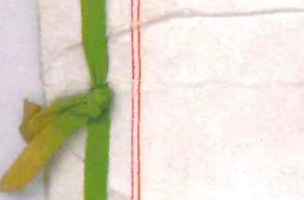

**-==:1,r-**

Term

Rent

**LES.SE:-·1 S**

**C0VE!f1..NT3**

'l'o pay cant

TO EOLD the same unto the Lessee from the twenty f:tfth day of Ma.,•ch Orie thou and nine hundred and f:Lf'ty seven f'OL' the ter•m of

**Nil TY 1•IIN£ YEA Fi.i:i**

I -- YTI ;J:iNG .A':!JJ- '_AY_fo,} the,•efor d.u:!'ini the said torm the yearly

l:r>ent *of* ,-I_P,JU :L,,S_payable by fvll!' equal instalments "in atlv,mca on the U-3ual qua.!'.'t:C-<;ays in each ,1n:i evcL'Y year free of &.ny deductlon whatsoever except the Landlords Property tax The first such payment

01• *n* proport.ionate part tr11::!'eof to be made on the execution heN,of ,

**2. THS L:Sssgr; h"E.-tEE:Y COVE.i\fH.NTS ·with the Lessor• as follows** : "'." ,

(1) To pay the r•,rnt her•eby :!:'ese:r-ved at the time and in manner

**bjsj**

**A true copy of the original Allsop Durn LLP**

**2 Midcroft** -, **Ruislip** · ··. **Middlesex HA4 SES**

- -·

af'o1•esaid without any deduction exc1rpt as afo.C'esaid. ­

toparyates ,,_G

und taxes 1

)_:r_<:p>a_y a."ld discharge all rates taxes duties assessments ct1ar-0es

**'I'o rl:pal.t'**

**E..rterio1·**

painting

and outgoings 1-1ha tsoaver whether .?ar•l iame nta.,:,y parochial or of any **othe1";denc.r•iption which nO\·J are or du1"inJ; t ha term hereby : !'-a.nt d** sl1all ba imposed or charged on the Flat o:s- any p2,rt tt1ePeo1' or the Lessor or the Losses o,:, the owner or occupier in pespect thereof (the Landlo,•ds .?Poperty •rax only excepted)

(3) Fisom tirae to time and clt all tlmes ch:rine: the said term well and substantially to l'epair uphold suppoC't clean mn intain drain anc keepthe Flat and also the stairca,se leading to the landinp- thet'eoi') and all adci.ltions Hhich may at any time o.m,:!.n::; tha said te!'m be made

to the Flat and the fixtures thet>ein AMO jointly with ti1e Lessoe or Lessees for the time being 01' othe,• flats entitled to 1..se the sarne

to re9ai1' maintain and keep the pa!'ty walls hatched black on the

Plan annexed he!'eto ------------

(4L_ _n the year One thousand nine hundrsd a!rl sL ty hnd tlw1'eaf'te!' once in every thi-r•d year and in the last yea1, of the said term wheneve.P and howeve:.• deter,nined to paint ln a colou.-• to be app1•oven by the Lessor's su_;:,veyor for the time being all the outsine wood an<l it1onwo.rlc of the Flat and all additions theC'eto with two coats at

least of 1 ood oil and white lead painG in a p,•o<Jer and •.• or•l,cmanlike

l**.m**l**anner**

I

. ·- _-- _

Intf::L'ior· paintl11g

oint liability hall

il( nce in cvery sevEinth year and in the last year' ,1' tM said lte.rm whenever and howeve,' dete!'.dned to paint all tne interiol'.' oi the 1''lat (and also th0 said stairca::io) ar,cl all additi.ons thoPeto

usu.s.l 01• proper to be painted with two coats at least of good oil and

.,1L,ite lead paint in a proper and,:or•kmanlilce manne1• and a1so at sucn times as last aforesaid to whitewash coloul' and paper si;_ch po,•tion

f the interior of the Flat as are usually sot .'.'eated

6) Provided always and it is hereby declared tbai:; the liability

*L'O!'* I ----- -

f the Lessee unde!' tt1e coven:i.nts contained in subclatcses (3) (4) anQ

5) he,•eoi' shall so far as relates to the landing colo.._rsd yellow

...nd odged red on the plan and the staircase leadin: t:iereto be a. liability jointly with the Lessee for the time being of the aJ 'oining

•'lat Number 12 in the Building and shall so far asrelates as

,,-.-.()

**SCALE**

i **ll,41**

*.l*

-**s1o**

**DAT**

i'oresaid be enfoa•ceable as if such covenants had been entered into y the Lessee jointly with such othe1• Lessee --·

'l'o yield u·o

**tZ.**

in .cepair · (7) 'l'Cl Y:ield up the 1',lat at the expiry 01' soonei• ceter-n,ination of

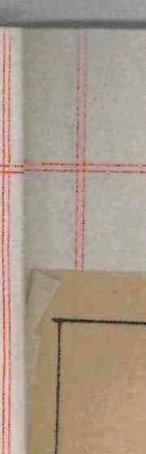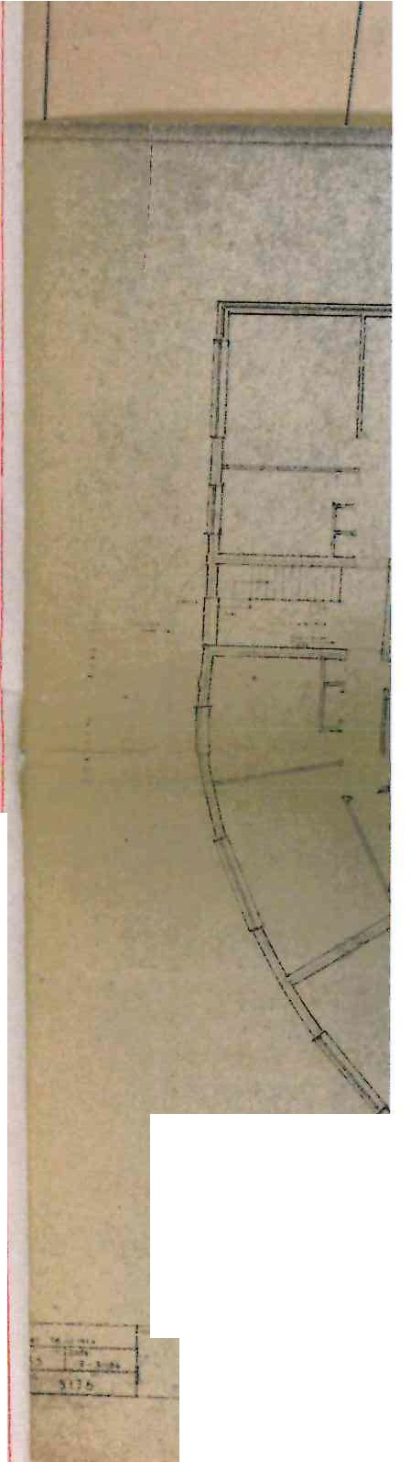

I



>Ol'.'t clean mo intain d.rain.

1ding to the

3 during the said

. NL jointly with tlrn Les see ats entitled to use

ralls hatched black on the

dred anC: sixty and thereafte st year of the said term

1.t *in* a colou2 to be a.ppPove

>eing all the outside 1:.JOod a thet•eto ,·Ji th two coats at **in** a pPouer and workmanlike

the lest yea of the said J paint all the interior of aLd all additions thereto

coa. ts at least of" gooa. oil "

LnlU::e mannep and also at sue·

>loup and pa.per

**t lly** so t .•ea ted **0**

* f *I\***r 1f *1f*** I

I • **fl/, *fr,***

-

....- ..-

*l* , I

,.....,**.**-......

*l.* ---

r

.. . . .' .

...

-..... .._

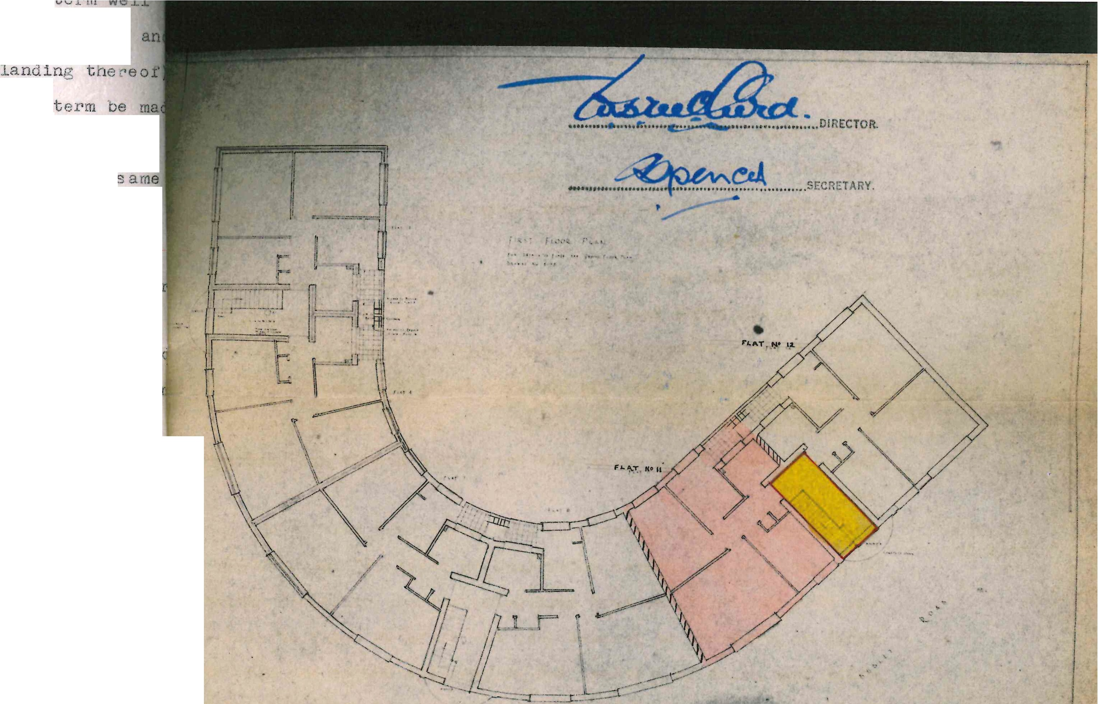

eclared that the liability

:1.ined **in** subclauses (3)(4) a

' -------- -

--•.:.. ... . .

_...................

...........-,- c.."-"".,..

'

0

<

0

a: r----

1

I

0 I.

z

*w*

#### n

: ---' _,

r.: - - -=, .

---;---·,l

I

'

1-1--1-T--,---

I I I ' I

C

E. Sc -e *,\t*

-,.

I 0-

1 a: I-

I I-<

! UJ I-

I Q. Cl)

- --,-===,_,.._(..

I­ i..:'7"-; -

6 I 7

s I 8 I 9

'"'

"'"'W/

C/)

*w*

it!: I :- -::::::- .

PUBLIC d'p SP*';ft/*

3; '-=- c:r-=iL-_..,-=-

iet_::: =·=:_- -.;.----

------ ""-

--- -

SERVICE

1 RO.AD

----- ------·------

--- ' /

/

0-- --- --- -·-·- - - - -

} ·----·

0-- --- -- - - -- - -- -- -- - --  ~~--·-~~ *~~--d?~~*~~-~~*~~-~~* ~~-~~  ~~--~~

·- - ---.,...-- 2: 0 N APPROACH

,-

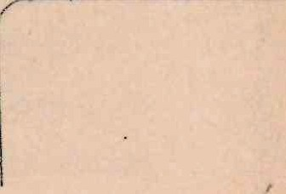

LE -1--

#### 5'00

45 DATE.

##### BLOCK PLAN

#### SHOPS

I

•

##### RUISLl'P

& FLATS

#### DAVIS ESTATES LT

346 350 KILBURN H IGW.RU.

22.. - 'so.

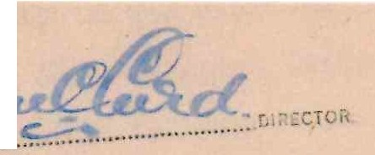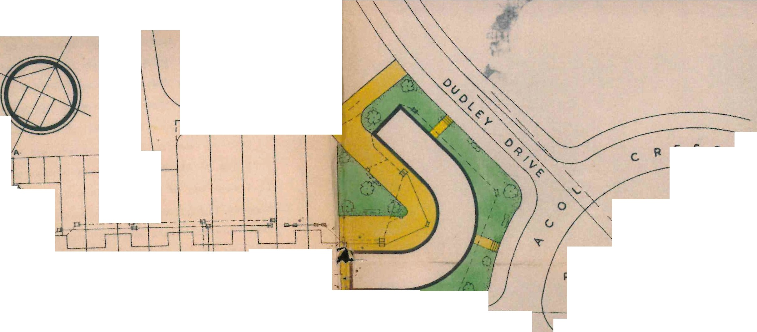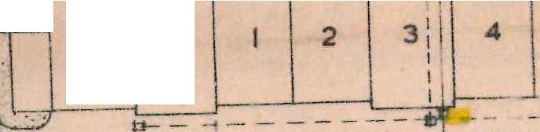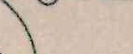

##### SOUTH

N, W, 6,

*- l*

,,

i

ii

_I[

GI

1:

1I

-1

-· *·::-*

lt-h, ,aid t,m in ou n ,tat, of,opal, deco"cion= coruli don ,s i:

accords witb the covenants hereinbefore contaire d to•01::tner with al 1 11

II additions an<l impr-cve,11ents t"-ade t,,ereto tn the mea'1time ::ind all

1· fi:xtcu'es of' ever:1 klnd in or· Ui on the ter-in may be affixed or fe.stened to or fi:xtures)

'let or 1-mi.ch dur.Lng the said upon the snrre (except tenants

I

ii

In•pectlon

by Lessor

II

I

### I

I

( CJU'.9 permit the Lessor and its surve ~or- 01• a ent with or without I:

worlr,r;en or others at all reasonable times aurin thess.'ld ter; to I

I

enter into and upon the •lat or any,n,rt Liereof ( ot::er• ,La'l t:t;e

stairc:ase) to view the condition thereof' .irtd 9le.o effecti::all, a,,ci

•\

11

substa.,tially to make good and restore all del"ects a:nrJ 1-1:ints of' Ii

reparation wnich shall be discovered on a.."l.y sucb c:xar,1i.nation ana of I

Ii

**which not.,.ce inwri·cinc S(1all be t::iven b:7 tbr; 1e.s or to tbe LE!ssee**

within o.rn calendar n,or,th afte1' ti,e l:Lvtn,:. *oi·* sucb notice

rlq,:.; 1•by

Lessor

11

'3ntr, .,, I1ad101.:11n I J.,eS<>6c.,;

(0. 1'o permit tbe Lessor if the Lessee sball make default in al"!y of I

11 tn-=- overants herei.nbel'ore ccntal:1ed for ol' r•elat:;nr,: to the repair ofI

I che .•'l.1t c•!' ol tue said sts:trcase('out-.ri.tboutpre,iui'i.ce to the right *oi* re-entry

1!1.ereinai'tercc.,ntatned) to 1:;nct:1' upon tne ,i'lat and staircase and1epa1I'

ithe same at tne e:x:ense of the Lessee in acco£d nce with the covenants and prov.i.:;lons of' t ,iese presenrs and the ex;,enses of such repairs or

I

I in 1i1e case ofre• olrs *ior* w·1cl.· the :...e& eP 1.s llab1c lointly i.tn a'l.otner *or* oth"rs the a,,proprlate pi•opor•tion of such expeneesto be deter.,ined by the Lessor's s·..irveyor snaJ.l be1•, ;;al.d by the i_essee h,

tne 1essor on demand

il) To per,1it the Lessor and 1.r,1:; te:1anss of. the ad.ioin.tn.'" flats

:1: 1iiers 8 \:I and 12 and t,1ei.1° l'es,Jecti.ve agent-s 01• wor1;:,,1en at an; time

! or ti.1:.es d.tr,ng the said te1•r;1 out o 11::1 ( £ave in case of' i.1:'._:enc:rl at reaso:1aole hou!'S and upon c v· n, reasonable notice tc, e::iter upon the II

'.Ji"lat so far as may be necesss.r-/ for executinc rei)all's or alterations j

' '

of 01' u-pon such ad.joininG premises or for construct:ing laying de;wn altcrln,:,r.0pa.1.rin cleansi.nt emptJin,.; Ol' mai!1taln-ln11 any se',>ers

Hater-courses cesspools 1 uttel's drains \ SL:;rpipes electr•ic ;;irE>s er gas

I pi,Jes in connection N.i. th or ior the accot'lmodation of the said adjoinir,

,lilats C!Hlsinc as litl:le da.na:..:e or d:i.stur:.iance as may be to the L;,lat

L

Ii. .

I

l!a'lu redtcrint the s arnc end the surface *oi* the soil andeve17rhing

/erected thereon to its !"onuer condi.tion·"itnout a:,y tml'e!l.scmablc delay

, ut without UJaking any cornpe;-rnation for any ter•!porar1 clar,1a;•e or

ii

II''

I 1·

.Lnconve,uence

11

· ·--,-,,,

··----·-·-•·-·-·-----------,-··--·---,·· ·

-¥:.- =-=---=:_::- 1L --- --·--------- -- -

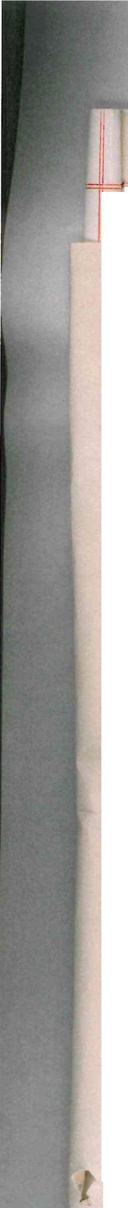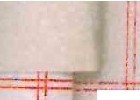

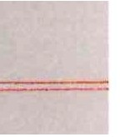== 11r11i: -----

I!let:rance Premium

( **11) Not to de 01 }:U.ffer anytntng whLc'b 1.lll o.r cuay tf!BJ{e void ox1**

vo:ldanle a."tly pollcy for the insurance ara.Lnst fire of t.he F'lat o,• of

any adioinine flat or which causes rm incx·eased premium to be payable for sue h lnsurance

Not 1:0 ass:lg,l( 18) Not to a,:;sizn charge unclerlet or part wJ.tb possession or part etc. pa:i>t

only

To reg is tel' asslgnments etc.

only of t11e flat er per,r,i t or suf'fer a:n-,y person to assign charge

und01°let or' part wlti, possess:1-on of part only of the l''ls.t _ ( 13) !ot to ass:l.gn or tra'i!sfer the demised p:t•e,o:lses except to an

ass.i.rr:1ee who shall conte.,;por•ai1eously w:l th such assignment or tra•1sf',.r e!lter into covenants ,1;.th the Lessor anc the Compeny in a i'c.rrc to be approved by the solicltol'S tor the tb1e i:ie:Lng oi' ti1a Lessn• to observe an.d perform the covenants conto..tned i.n C.Lause 3 ·oe1'eof en6 Hitl,in

h1ent--y one dO.J3 u.tter the date of any a,:;signment un(lerlease or other• uevolution of the demifJed premises at his owri cost to cieF·;er to the Lessor's solicltors fer tr•e time :>e:!.n[: ,Ll abstract i"ron such ass.Lgmient underl,1ase or 01:i1er docm.ient cor,tainin;,: the <,ate tnereof

the !'lo.mes s.nd ue!lcri.ptlons of tl"..e ,,arties t1,e1'£:1-o and S;)Gc:Lfylng the I

I

party *01* parties in wborri t,1e or *en,'T* lE.il,al estu ..e ls tt,eretJy vested

and wi11 at *ar,:;* tlme 90.y to s.Jch Sol:lci tors a 1'ee of one E;Uineo. in 1/

res·,Ject of everJ such deal· nt5 ·-

Use o-:-ily as II(1, ' '''o u,ie and occt..f,.f tne •'lq,t as a r vate U'.·le lin; hou::ie in one one dwellln!L

!'lOU:;u :; n le of 1'y, Lly occ;µo.tlon onlt 1.ma noc for J.11 · U-er our-pose

1 ot to con,-1(15 i1ct to <lo or c,'lllt or peL•r1lt l,o be Jent: or o ,itt'o a•11L int.; in

To **pay Ge.a** an!l Electric_

l'o obser•; leguJ. at i.or

travene •own t'lannln

Ac ts

the ?lat tne dolnJ or omL1s on ol wn' en sb,-11 ·;e a ct...;ll cav<"ntlon o! " e 'Iow,1 *::C* C ,untr l-la"lnln ,,ct 1;,,,7 and to lnae ,;n 1/ t,,c Lessor

* ainst all actions proceedlnns da,a es peuKlties cobts c ar0es claims nd de,,ancts in respect of s':ch acts or omissl.ons

To p:;y co of Sectio.

146 Notic

,fot to

maira Ol' injure

cut

16) Hot to ctn ma:Lm or in.iure any of the p1'incipo.l ti."nbers roo1s o.r

,1alls of the, lat nor erect or :suffer to oe erected s.,1y ne1-1 build:i.n;.:s



·hereon or ma\re any structu:c,al alteratlon or addition -co tLe ?.lat

,·lot to mak.e If l?) ifot · o eract upon any part of the b'lat any bt.1.i.Ldln" w"1ether

al ter·at.ionB

-·

emporary or pern!a"ler'tt other t<·:an the 1i'lst hereby de111h.ed and not

* + lthout the previous licence in writing of the Lessor or its surveyor or the time being to malrn any alteratlon in the plan or elevation

f the sa:i.d ::O'lat O.t' ln any *i'* the party walls or in an;v of the

-,.,rinci pal or bear.ln1 ,•m lls f'l oors or timbers I

Lessee's **cov e{1ant** to ,,arden e.;c.



To insure

18) .At all times du.rinr the t; err11 bere.,y 1:rantcd to insm'e and keep

nsured the demi ed premises under a i'lousenolde ..:s compren,,ris 1v e po lie·:,

*(;~~:;....-==-~~·*

=r==i==== = == == == =Jd

I

### I

,·*>'*

;

II

Ji

for private dwellings ( all i te:,1s with no exclusions) to ,e i.urned

**ke void or**

II

the F'lat or of

m to be payable

**in the joint nai·!0S of tbe Lessor arrl the Lesse0** *::>:.:* **tne .2un Insu.t·ance**

Oftice of 307 lincnley doad in the Co• ty *ot* L ndon or S)Ch other

1s,on ot part

ri. :n charge

'lat

**:cept to an**

ient er trans :f'. r

n a fol'ln to be

s: dcr to obsflrV,,

**r an_ *vrl* ttiin**

lt>as Gr othe,r c.el i *•Jr-* r to the **1n suer,**

,,ate t-,ereof

s pcci l'y in'., the

ierA•,y vested

'I!,.

'

insurance office in the Ul'll ttc. .,..ingdol'l as DY frc-!'i time tc t:ir.ie be nom.Lnated by the 1.cssor -1.n tr,e £elm *oi* Two thousa•,<.. five h1,mdrEod 9.'10 l'il ty pounds or s·c1c,, ot:1er su;,i s.s the 1 essor shall from time to till:e declare to oe eq1;.al to the 1'ull value t,,er, of." ( lncludin[.; proLe:isl.0:1• 1 fees incurreli in reinstate,1e'1t) am! to pu:, all pre,ntlli"lS necessary

for-that purpose t·Jiti"Jin seven day after 'ct1t' sarne stiall beco;,ie due a:ict whenever required to pro(1uce l:o the Lessor the µolicJ 01· such insu:c-ance ane', in case of ooy damage or destruct:Lon to the de ii.sed premises fort',\·Jith to lay ou the insu:i'ance money in rebuildinl: or making cod the dan,ag,, sustained in f.!ccord1.r:1ce We.th *ur:·J* atatutor.v or

local enactments for tbe t i.m0 be: ng in force snd to ,1;,,,,e up an:,

**(leficiency out of his own mone r PRC:VI!S:IJ ALiAI0 tl1ut lf·tbe demised**

**p.r1emiees stall not b kept insured us a I'o11E!sa.l(J tbe L•essor ,r;.9.J insure**

I

I

ti:1e zame and pay tlle p1•emi1.1ms ano the amounts tLoreof s·nall be re:x,iu

1. ':Jy the Les;;ee forL1,1-Lth and unti.l pay.1.ent thereof s:1a1l be reco· e.rable1

DJ dlstre•s as er rent ln 2rreor

**.ne guinea in**

**ic,une in one**

* + purpose

a•1vti-ling in

.travention *01*

t.;e ·wessor I

a cnarJes clalma

·ro pay Gas ana

Electri c

.1'0 oo,., .;rv e

te)Ill.J.St,on

II(l'.:1 1'o p -r !J. 1 car-es 1or as an..i eiectric•t,., su,,lied to t·,e r,1.,t I

s s·ie,,n by separate meters al'1ived t!",ere',n a,1d tne cho.rc:es 1or suer,

-ters and to ind<Jmn:1.fr the Lesso. in respect t,iereof

( 20) 'I'o observe and perfor:n the regule.t: ons set out in Part IVo.f the

;:,ciledule hereto und such other reasonable 1'egulations wbich the j,essor

r.1ay frem time to time maKe for the proi)er mu"lager•,ent as a bigh-clacs resiaential bu:llcling of the buildinr of 1-.ibich the ?lat fo1•::is part

To i-:· Y co..:its II(21) *l'o* pa.r to the Lessor el 1 expenses ( :i.ncluuinL: 3ol-tci tors' costs

of Section

**nbers rcoJ·s or**

***f* ru::w buildtng**

to tr.e *l ;B* t

Of whether

;eG and not

)I' its surveyor

,r elevation

1 **of tbe**

l1l'e and keep

**ei:'1ens:i.ve polic:-,r**

l4ti !otice

I

Lessee' *3* COVb!laut us to Jarden etc.

'

anct Su.i'veyors' fess l incurred by tbe Les;;or inc· dei-,ta:i. to the oreparat:Lon and service o.1 a noti.ce \.illl•er ::Jectica 1-,G of the lai; of **froperty .'. 1ct 1925 notw"1_t b. ta·1dint3 that fo.(1fei..i:U1'te is avoiucd ctherwise**

than by relief granted by the Court

**3. Ti"I2 LESSEE J- ! Y_CV_\!_ _·,J.A.i{l_i?_ wit ti the Lessor an<) as a epars.te covenant w .t tt.1 the Company to Pai to the Compa:1y in e eel·• *y-* ee .r a su:n eq\J.al to on,:.- t ·ielftb of the 8[:::.r-e _:ate of F'Irl-'1.i all eXi>en(ii t,u.1:t reasonahlJ and i)roperly iar:urred bj" tn( Compan:r d1-1rtng the pI'evlous** calendar year in µerfor:nln.g the covenants 0'·1. the part cf th,- Company

!set forth in the st1cceer,ing clause hereof and in insurinc ln the joint

1a·".es of the i.-essor end the Cor1pany at';ainst ',·hird Par•ty claj_ms me.de

###### II

I

II

!l Jj

## ·--·--l··

I

I I

I aga1nst Llle,n or· e• tuer *oi'* tuecn in 1 espect cl' t ·,e la,•vis carue:1s

;r I:1

. ,,","'Y, ,

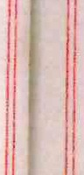

II

**11**

I"'-



Gompuny 's **cove.:ant as** to *:ta:rde!l*

0 0 0

footpat,,s a " ca<'rca *.e,•rn.J* ancJ S•:C•,.·f:J a•1 a·''ount eqm:l tc- 'Ie:1 per ce tu·•·

**O.L s *er·* e-xpenditv.rt: sucn 4:110Ll'1t ·lei.r: ,.>.9,rbte to t'.•·) Gornp ::inY** as a

1,3,,e,e"!l ree s,c *s.,m* tn '"' '1LU tu tt,1.: (,0,11;:,any w. thin one month I

I

arter o <le *1,nd* tn wr t *,.,c* t ere1or n2s 1i.01. left at c:rs enc by po,,t

to t!h. .?l,, t aJ,;r sf.t:J,l to ''the esset:' t· ereof'

,1, '!'r:c_CG1·1.!-,VTY_.E':1E,lY_:;ovs:•. _i'.rS with t'.ie r,ess..:ie t!:',at the Lessee duly

etc.



.SES:30H 'S COV;DJA.h13

**Quiet enjoyment;**

payLnr, to the C,smpany tne money,; ?t,yable un::e11 the last f'oreg,,tng

clause hers;of the Uompaay at all tlrnes cil'.111.nz ti,et eur, rrnreby granted

will mainta:ln ,nd l,ee::i,n good o:rcier rf,pair rmd condi ti.on as a 1Scwn

or ra:rden the land coloured :?L'een on the !.:state pl,m and i-.ill repair maintai!'! andclean the footpai:hs and the carriaco;eway colc'..lred yellow

on the plan

5. THC L, SSOH :rrn:r1J13¥ 9u\/:S1A.q,1; With the Les.set as follo,.s:-

(lJ That the Lessee ?aJing lhe said yearly rent here:7 reserved and c"ts ervlng and yerl'or,nin.,; trie covenants a>1cl cond:l ti.or:s 0'1 the pr,rt of the Lessee he.t•e:L:-1 conta ;ned shall *1:u:1<'!* rnay peacec,bly a>1ci quietly

possessa 1d e:i,Joy tl1e demiser.:i premises durtn1:; tbe m1•111 hereby ranted

1

I

/, "'"'rv '.ce oi'

1/ d0t:i.oes

onsrrwction

,1ithcut a:1:y lm ful i.nte:r,ru;:,tion oi:• disturiJm:ce by the Less0r ora,1y

LJe?• so".l claiming under the Less or

iIlenrsau::..•.ar11oaenodf' II (8\ Ti at tbe Lessor wlll not dur'nf! t11et t:r" hereny granted grant

a**p**d**r**,**e**i**m**oi**i**n**se**l**.**n**s:**:J

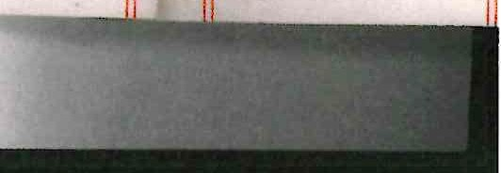

'I'o pernii t Comp2.ny to **enter** rarJen etc.

··-··-. 1-

1

any lease ort e:1a;1cy of t:ne premises l1r., s11iatelv below tbe r'let and

,moi.m as ,,·lat fTo, *\J* save upon terms tnat the lessee r *r* te1ant thereof co•Jena,ts fo,. tner0µa:Lr of the sa·a fli;t 'o, *\:I* ( i<1cl,cilnf.! 0verythinr; below i:!1e level oi the unc:er1oide· of. the con,1rete rJ.oor w•1lc':-, r'orms

the floor cf theflat he:re:1:1 ae,nised in the lik terms as are *:,et* out

in Clause 2 (3) hGreof and to tnsu1,e the soi:cd Flat Mo. " ln the like

lterrns as are :mt out in Glt, 'Se 2 ( 18) he1•eo.f t,W.fIJ:,;D AL;JA·,:s fdD IT I::;

l:'.::E•JYA GRK,:D that in the event of the assignment by the ,.e.. sso: of the ["eJersion imm dL,atel;rcxpec·ta. n.t uponthedete :cii:mtton ,of t rnt errn. .

.1ereL>y gran tea t:1e Les so*I'* sr:a 11 on anu fr•cm t:,ea ate of sucn as s:ir:n>ne:11:

**If enaa to be lfabla ln•.eepeo, of enyreach oc bemhe, of thle coo,na**

· !'llch ina.r occur after tnedate 01 su.ct1 ass1rn1;1en·r; - _-

113-;--'l-'h·at the Lessee duly :,ayir'lf the monies payable under r.lsuse 3 ereot· the Lessor '.•ii.11 perrnt t tlJe Company its servants and agents to ave access to the lend colou.ed yellow on the state plan *for* the

**rnGlau,o 4 hereof** -------------·-·······------·-·--·-·. ··- --·

··•:r-1====

Bl' ins.l

**··10 te::;**

Cer-r;il ica le

3 to v al-<e



**.c-d.cns**

**T·e:1 per ce tu1.1**

**Proviso** for

**/** re- '1try

prcmy

**one**

as R

**month**

en t t.::,- po·-.t

e Lessee duly

**fcrerr.. i.ng**

**1t .re· •.i i-<ranted**

**'-'1** ;::s a la ..in

**will** rspair

.c-u.r-ed -yellow

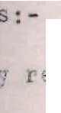**reserved**

**ns** /"\•·-..**the 9art** an, 11.u etly **ereoy -rsn ted**

.,erv; ce of

•!ct i.ces

Conslruct'.onll

**=ssor or en_y**

-,--ra'l ted grant the •'l:it and te,ant thereof **t.ri:1 r:-verythlng**

ur .in.:ll

·Jotes

**l-;1:i ch**

**l** *13* are

**forms**

set out

Certi.i'.icate as to , ulue

**in tbe 111-:e**

***JA"-::::3* l1ifD I'i IS**

**e Les iol of the**

**of the**

**such**

**t er-m**

**assi .r nn10n**

of tbis covenar.

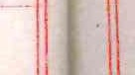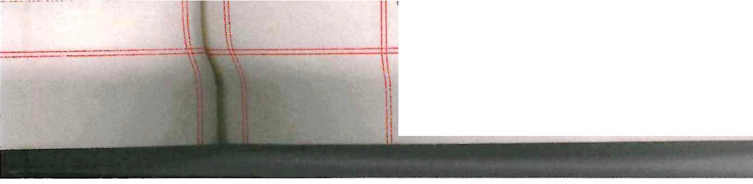

|  |  |  |
| --- | --- | --- |
|  |  |  |
| o. FrtOVIDED _Al,'.·1..£l.LS t.Lat if the saiuyearly rent hereby reserved or any part thereof shall at any tlrne be ui11r,id for t,rnnty one clays afte the same shall have become due whether the same shall have been legally cler,,andec1 or· not or in :.: ase oi' the bi each non-pzrfox'"Wnce or non--observance of' a-.1y of the cove.1a1 ts on the part of the I.essee herein contained then Bnd ln any such case Lt sr,all be la•.-11'ul .for tbe Lessor or any person nutlioriscd by it to c,nter into and upon the aemised premises or any part tbereof in the name of the whole a:ici to  **-repossess tbe s a.me as of i Ls former estatt-1 and the1'eupon the term** hereby cr,,nted snall absolutel:9 deterr-,ine but without prejudice to any right of action;or *remed·r* of the Lessor in respect of any breach *oi'* any of tbe covenants by the Lessee heretnbel'o;:•e containeli. _  7. I·i' IS H A >.I.'.'._}I.G\iEEl> that an:1 notice he1°eb;/ required or authorised to be given to the Lessor 01' the Lessee shal'l be in \?rt ting and may  be glven in manner provided by Section l d of tbe Law of Property Act l\·2 with res,:iect to notices to be (T.LVHnto a h,ssor or ls:.,:sec. n,•er that Act  *.i* IT .:.::,, h:1>tE ''' A --G";-;.) t, at l1. t1 ls l.,,,,se; , el't,rbCJ.Cc to ony Act or  Acts of i'arllane.,t s11a.L.1. oe consu• <'d as tuc.L ....... n- relere•1ces to sn:-,  statutorf modlficat.on or .r-e-enoctment therenl for cne time neln, in force _   1. Th8 rnargir'.al notE::6 shall be aee• ed '1ot to fo.rt" rrnrt ofu:iese prese,:i.ts and snali not t>e taken into account in the constrc1ctir-n o,· Lnt,;r pretati on oi any covenant condition or proviso here in contained 2. I'l' IS HTm3 iY 9K1.l'TJ' _n:.0_ llat the t ranc·actlon hereby effected does not forrn part of a larger transaction or of a series of   transactions in res ect of whicb the amount or value or the an-.re::at amount or value of the con,3ideration other' than the rent exceeds  **·rhrss tho\1sau.d fl ve hundred pounds _**  I ,'f _ W _I 'I'_,q ;i: ·"'· S whereof the Lessor and tbe CompanJ bnve  **hereunto affixed their Common Seals and tbe Lessee has bereunto !;.t=t**  his h2,n-;1 and seal the day and yca.r l1.rst be.fore wrltr.e-,  **SCFIEDUL'E**  jlRT I_  .t\u, 'lliAT flat known or to be known as Number 11 on tne first floor of Langhar;: Court Station Approach Soud1 :=l;J.islip .Ln the County of i'lidctlesex as tbe saio flat is sho.-m coloured pink on the Plan  a·,nexed hereto '.I'OCfa'fiiErt ·:/ITH tlJe first ffoor landing coloured yellow |  |
| '· |  | |

er ,,11;.use 3

and ag,ents to

-lan for the

om;?any containel

,,

11-1(-, ,d 11

I

I

**eu** " **oetc** sa'id 1011 a'"ln ad 'rl•,it• t·'le ;,a.ct flat **-,hich setd**

1:.lar, a10 lar.,:i.n,1 snall be deem d tc ir:c· :iua tr.•e concrete floor- fon1lnc;;

JV·e r:rsl 1loor or

I

Lbe bu' 1.Jln- t-u' nc1. tile ce

lir..- plaster affixed

1to tJe W1,ii,rs:ce **o!**

S"C" noor o'1a e•!;r.fi,hl.n: ubove me level or the

.mde1•.:;loe or s ·c·::-, **flt•or** S'1Ll n Jflrt,cular so muc1i of t:,e roci' of the

b du !.tS •" 'If: ca-l.1 aoc,vP. tbt sa' d r:..a **d ia - J a dto**

**also sc mucn *oi* sny pi i ::utter or otn r chin dri1 ed to t e outslde**

**_,1g:2t to**

**pass alc-ng**

i 1·,ts include

i demise

**Ease enta**

**0£ Aca ss**

**f ti:e sn'Ld flat a.·t<.i la·•'l<J. ng a ': s at>o·,;e th sa!.cl level**

i'Ai T *II*

1. **'1:he .r.lt{:1t i.n co rn.non - ith t 1e Lessor ar!d i:.l e laasees or occupiers** for the tlme be:Lng of the ccr1<:r ?lat::; l::i t.i,e '3uilci.1:2, a···cI all octei's ilhavlng the lLct r-,c:;,:t to use l'or purposes of accesE: to and et:.-ess fr•cn ***t1 e* Flat first theEa:rvlce toad and paths coloured;ellc'lii on t ·;e aa1u**

**·-:nt:r=anca a::1d taLY.C**

Si.\_Jport a,1.

frotection

Passa,r.,e of'

.later· etc•

)l:;r'.', *a:ic* secc,·d t:•. 1 ra ice ,1a 1. l sr1::c s ta,;.1'ce se lea ·!.:::tg *.t* ro·11 the

:r,·,und flc,or :·.o t•'e L •wTr: of tb'! :l'l$t _

**.-i.c 6SS for**

ad olnin;-'

Ease,e"lts

i 2.

r··"•

r l'.·nt n cun•mon ,,,th a7.l 0·1:1,;,rs £'or the

t ir,,e i.1<::.Lnl !'laving the

**Le sees**

of ater et .

* l i. e rl

.ht of passa

..nd rJru1•;I'\_ oi' ,_El!l electr,ctty watr;r- ard sotl

bU,_);JOl't and 11':ro·,;"ctcon

l

**lrom and tc- t1.1a t 1lctt throu,,_;h the .Jl ;se w!..te;J cc-ndul ts n-:H.1 o.r ins in**

**,.·ncte.r c•r 1.t_:1011 *t(v:*_*.*,.1Lt.i.1G!..Y.?,;**

- 1ll o ch r•. ts of support and Jrotectlcn as aro e j ;ed by the

* + clat from the ct,1er flats id1oin:in,I L1e S'.lc:,c at t•v, d:i.L"" ;-,creo'

ig:n'.:.s **or**

- he

,.I.L. swns an•.1

I

iiv:naen::.

--r.-trht r.o use in co,,1.'!on ·,.r, t

**.1.ie.:> 0-"**

**.;:;B'S 0**

I **ccupi.:;rc _ ".'J.:1** U_r• "' ',• **..,i...** (

**t in t.l1** ,ul

,1i.n

., -- I

,U ··- II

,I

1lsltors the law'ls and . rdens coloured

re,,,,1 nn t1u

·:,, l & tf'

.Ll.1•1 I

I

I

ubject to sucn reason9ble? _·..tlen E.'1J !'AJ lnt ris tor t0P. co Mcn enjoy-I

,e.,t thereof as tbe

**Lesn r**

"'OJ f'rum time 't<,

int.

r£:;;:cr' ·, I

:i..ccess to

adjo • .1.i:l,_.

J:,_e rliint ( to ***e* cxerct- cl suve**

:1 ll c,.se of ur C on

,,., I,

.i'lat

•, easonable tir1e s and upori

**•t... Lr.:**

**ver1 ,•t;.:t.1.tJct1.U·LLe TJ.Vt'c**

to -,1tt>r upon Ii

he premises actloi:1.Lnu tne

·lot and l:1 p9rl culo

*1,.,0•·.* t,1e 1 lat known

- **1:**

h

c Jc. >i t'or ttie pur,c, 1e *oru..1 oL* execut in,; a'.1y teratlon" to tr Je isea preml•es the esEee

necessary repaL s;-:..'1d

ca 3lnc as l!ttl0

a <.. **di st *l* Ji.., Ctj** 2•1.J l'1cor1ve:-,ie'lce as :Jossible and maKl:ir: good all

la s e occastonca t erenJ b t wtt

e.,,porary da1 a,,e ol' inccnve-1lencc

'>I

co pe'l atlon for an

Je,"e fit oi 1'l.e3ula t Lens

The benefit (in so fur as rne Lestrr cmc rrk tr.e ;;a :e) i:1 com

i th the ·.essor e.nd other persons e"'lt.,:..1..,ct t rd o **c-f** :::·w cove'lElnt or

gree,.1ent entered l:1to by a les:;,ee of an, lH ..,r l<,c **tr.** the 3uilc.:n:­

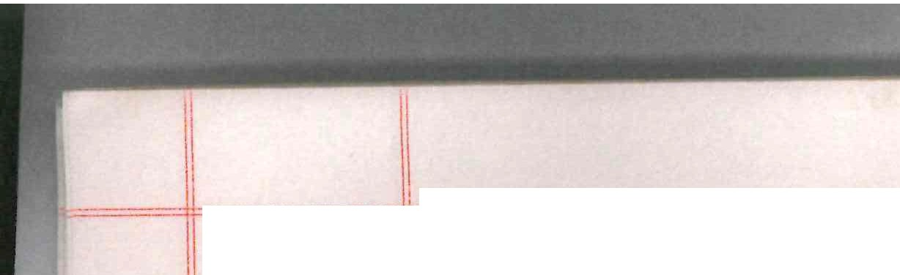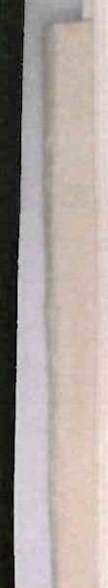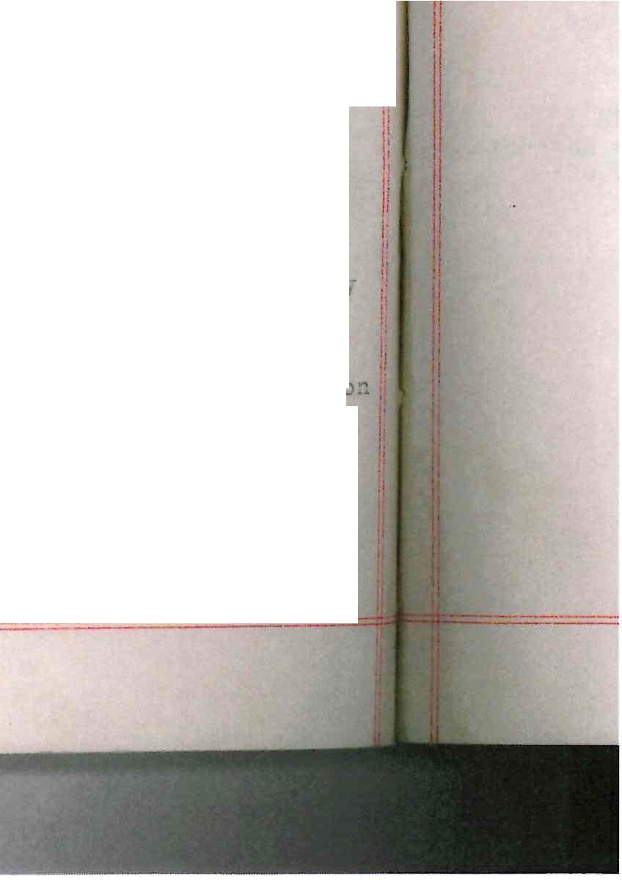

i th the Lessor *i'or* the observa,1ce a:1.d p,;;r:1'.'cr"1n'lcr. **c,f** t·1c re· ulotions



-

·11

specj_fied in the Sched;.;le nereto -----····--····---

flo<'r for-t·,"i.ng

**? 1'}1_e rignt in con:mon ·,,Ji tb n:tl others for t.:te t1 r.e bei.nr:;bav:i.ng t.,c.1e**

ter a11'ixed evel o: th,., **roof c,1 the**

**n1a tc incl**

v,e: outsld,,

**utP**

lil{e r"lgi:lt for plac:i.n;; an usl.ng a refuse bin in tl-ie refuse bln

**enclosure I'or-.n1ng po.rt of the Ground PI0011 Plat lio. 9**

PARJ.' III

**11:xcEP_ s *1\ \Tl)* R':1SEHi/ *A* TIQ_ 1TS** _

.ii[·ht *to* 111. '.l.'be ri1cht for tbe Lessor and the lessees and occupiers of the poss along - ·

**01 ccc.. pier;:i**

1. **a I u· :hc:1-is**

**:1d** - · **r e 3 s fr c .n**

***vi* on L: *f'* sa:1.d**

:1.ro'll t ;E;

* + **,·;:itrance Y.nll**

a d .:::tairca.,:e

su_,port and

Frotection

**Passa e oi**

ater etc.

**adjcinin flats Wes. 9 10 and 12 to pass B'.10. i e-;as..1 o ;l:!r and alc-ng**

tbe seid la>.1.dLng

1. _- uch ri;;hts of s u,Jport and p£-otectlon to t.10 1'1ats adjo1.ni..n_s tiie

?lat us are now e joyec from the lat

1. Thefree and uninterrupted f)assage andrunninr: c,i wat'.0r an.Cl sell **ias ana electrlcity fro; a d to tl1e other flats in tr1e luildtn** throu[:b ti:ie pives 1-Jh'es condu.i. ts and d1'a:ins in un.,e!' or upon the ?lat

**n:J hav t r t·.::.r:.**

< e1' ard s

d ura n:; •n

Access f"or adjoinin;_: Lessees

_,.

'flie right for' the Lessor and the lessees and occupiers of the

adjoin.mg flats Tos. \:i 10 and 12 to e'1ter upon the F'lat or any port thereof but onJ.y tsave in case of ,,.rtfenc;;l at reanui.able tirnes and upon e;ivJn:_: reasonable notice !or an,· r,f the 1ur1oses and sub"ject t.o

**;,e 1** *';:;'* **t.,n**

**ll reef**

**c.3···;.: s or**

**ili:n ts** o

.Li_ !:it

: Ln-, rov's'on:, .'lentivned ln "!a.u.,e 01 ,art I *o1* tins . c,,euule

\ '\::>. *'l* "' .Cl nt ror tbt: vt::ssor st any tirrit:: n1:,reafte1 to Julhl er rebuild on a"l, adioininc: or nei.chbourin,: land other tn:n t11e !e,r,d coloui-ect

,_;reen a,:16 yello;-1 on the Estate plan accord-tnl_! to stich· plaris ( "W°hether

**l'n'-'** a'ld th_;ir

& **e :.1lan.**

**co"'Jme;n e:1jo:r-**

he----

only at

**to enter upon**

Le flo.t known

**renai : 1;-w1d**

***s* l ttle**

**inr good all 'Lion io.r any**

**r.uae) i ·1 ccmr:!on cov 8;"J.f.i.nt or**

**the 3ui1-d-Lng**

**c r·er.ulati.ons**

**as to heigr t extent or other1-rLse) and in such r.1anner as the Lesso11 shall think i'it notwit::.sta:1ding *a':lJ* interference t:jcreOy occa.sioned**

to the access of licht to t e Flat

PAHT *IV* i

**3'8.:C!Ui,ATTOI,TS**

l. Hothir_ig_shall bs done upon the ?lat or any part tbereof any act I

I' thing which shall or mc1y be or become a nuisance camar:e annoyance or lnconvenience to the Lessor or to the lesEee **or** occupier for the

ti.me being of' any ad.Join.inc or netchbouring flat or to tbe nelghbour­

,.Jood

-w Jo_._:_erson of unsound r-1ind or of drunken or irnmo1'al habits shall 'pe permitted to reside in the flat -----···

I

r-'...._::'.(?_Hindows or li;:hts 0elon i.ng to the :.:<'lat or t; ile :3Ulldl.n;: of l·!hich

!rheFb1t f'orre;s ps1,t shall be stopried up dar·he;-ied or obstructed

music orsinr:ing Nhether by instruments v oice:z wi rFJless

1rra.aop:ionet elevisio11 or- otticr nic2ans sr.al.l be allo1,1ect ln the -lat or I

I

JIL

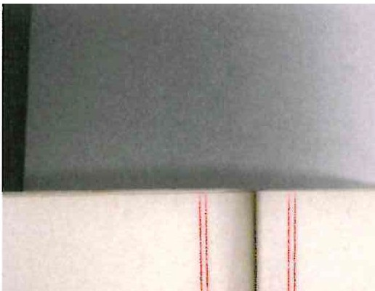

I

L_1



I

II

Jl

IL! _



l!l,

I the

o,

3uildin,; betwee'.1 11 p.r . and ? a.m. _ Nothing shall be t1eposited or left int.he C::1tra1ce br-tll st:iLcways

**TctE COI;lf':GN S'S**

**, ;,**

·----·--- -

*or* passares oft he Build:ln , ne:trier sr,al.s anv carpet rrat or rug be

**i.S;;_ A•I1 S :; A rAc-**

heret:.nto affi

**of:-**

beaten or ch:lldren allowed to play c .erein nel t,,er shall the sat>,e be

in any ,,m; obstructed

?· do person sl,all :r·,,side in the ti'lat unless the floor the1-eof

( includin,:: tl:e assa:,,es) are covered ,ii.th llnoleu,1 carpet r'.l_ s or

I c-tter sutt ble ,,:;iter"tals except wL1le the sar e s::;all '::-0 rt:r,oved for

**cleaning repairinE or dec atlng the Flat or *Io* some temporary**

purpose ( Thls ilei:-;ulatior1 ho,,;ever not to a,,yl:; to a ,'.r.~und floor flat)

i ..2_: _;fo flower pots 01' otner thin[,s shall be placed outside t.!ie wJndow3

11

I lof the ?lat unloss securely fastened to the w:l!wo·,i bovts ,JI' ,v11.ka tc

jthe c;atisfaction of the Lessor

I

...

d.

Ion

Er

I

conv e"1ie·1ce or di st·.iroa ice tc, a::1:7 other per scn Js ln'- t re s a ,e

fo advertlsc:nent or notlce *o.C* any <::escr ptLon snall be placed on

-·

1'.fot to use or permit or suffer- to be used tlle lJnd col().ll'etl rreeD. the plan otherwise than ns a law::1 oi' .:.;arden and ne,t *tc* do or r, rmi t suffer to oe cbne thereon anythinz wr.ich woulu*.oe* a n'-'l'>'.!'1.ce or

ti:e outside of a.'ly of the walls or d,ol'S c..,t tr,.;; • lat or the Juildlnc *ii*

except

·cl,at tt-e name o.!' the Lessee ( w: t'-10 .... L *a..-n.r* notice of the

profesaion

or business of the Lessee) may oe painted or affixed

outside tl1e u1tt:.",ce door ot' the I-'lot in !mcll style as tbe .Lessor shal

**qa cove** l\

lie. ot to leave or park **'.l'l** ·otar *or* olh.-,r vei.'lc·e t,, t.,L carrtq ewa-<r 11

,I

iladjoinln'-­ the rear ••--i, ,ui ldln, so as tC' C *e* 1.'l **nee or** ¥'\-

/1conv e_ie:i. lbul ldin

I

###### I! lf..1..._J_gt

t" rtx a 11tr•c1e::ss OJ. teltvls oneerlnl t

e lo **the** es3or er *a 1* lessee r occ p.er or *::ir,J* i'l::it .tn tbe I\

the bXt<.rool' 01 the

j>ialci flat or builJln but <-lk _l be ent l tled to '.1se s1:cr. tel€visi.on

-er.Lal as t,1e Lessor may erect on the roof' of tbe sald bu.tl•jJ.n,'.:, the

**ositicn of such aeti.el to be at che absolute discretion of che**

**.essor _**

- -··.-

----··---------

_JL ~cc,: -*b--:1* S ;:;;Al., of' DAVl'.S



CC l·f'c.tAG"l'C RS LHlI'l'ED was bereur to affi ed in he preie ce of:-

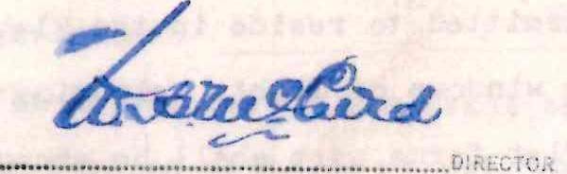

......... ../·**.::•:;tt:· :**.**, :*e*.**.***A***..··•···.SEC, -•··'

\

.

,...;.

###### ii

I

stai W9.'S

',r ru,; be

**!1e s a -e n**

el E:Of

'I':iE c0rn°.0N SE L of' F'LATS Ai';D )

**':1';)·.!.1.t 1'S3-:A-,\TF.r- ":-1:r;l-:T Lli·1I:!3D was** )

here:.mto affi, ed in the presence l

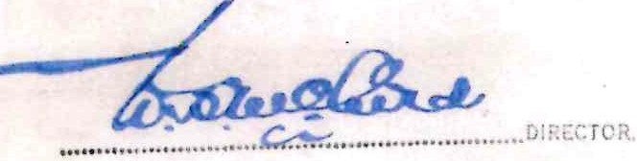oi: - )

rc1 s 01

,,,,ov ec for

**>orarJ**

flc,or flat)

t.-i*e ,,1* l naow s

.>rcvidea tc

**o·irea r're ri** rlo or p0rrrlt t'3'.3'1Ce or

es a"'.le placed on

be 3uild l n,,

the

*t'tixed*

LeSEc<'r S'lallj

c:;1.rri,ic,-e1-1ay

ce o.r .n-

***r* f1gt: ln tne**

**r r of t!1e** 1, vis'lori **xiloi.n.: , t!Je**

, **.f - ie**

ffis

as hcreurto

r,ce of: -

. \

*.... J* ·,-:r.-,

--········

*i*

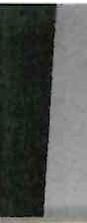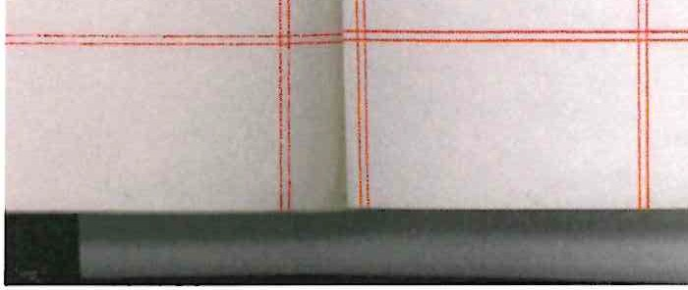



**7 =t-'4•-C,,** ;..--· **;e**

DAT;:;:!.; *,P LL '* 19bb

,,VIS cm, ; i!,--'IJ iS LLUTED

- ana -

J:"LA'i'S & C: 'l'A'I'ES 1·lA ;AGE1'1EKT LE.!'ld

- to -



,._,

***Mi 35.St{l_/***

**Drt. Fe. LAKE**

**ea@**

- of -

PLAT H0.11 LANGHAN GOlFiT, STATIJN

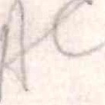,-1:'.->iJAGH, SOL'IH .(UISLIP in the CJu;-l'.Y or MILlJLT::SEX

TE ll4 : 99 YEAl!S

l" OM: 25th day of arch 195'7

£N'I : £lll. 0. 0 pe!' annum

*':"* -:.···.: *.;::::-:*

**" ,u•v**

**H.M. LAN**

/: **TITLE Ne,** f.v..\,/x., -,3....::;.;.5....6.....,.,..!...........,...,..

Lf'*/*

*·t*

.i \,lj,k

**LEASE DETEllMl j 0** . , . '"

**D TE** *15* · I*·CjS*

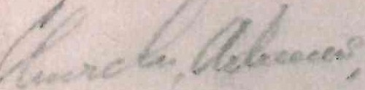1I ».

